Reports Documentation

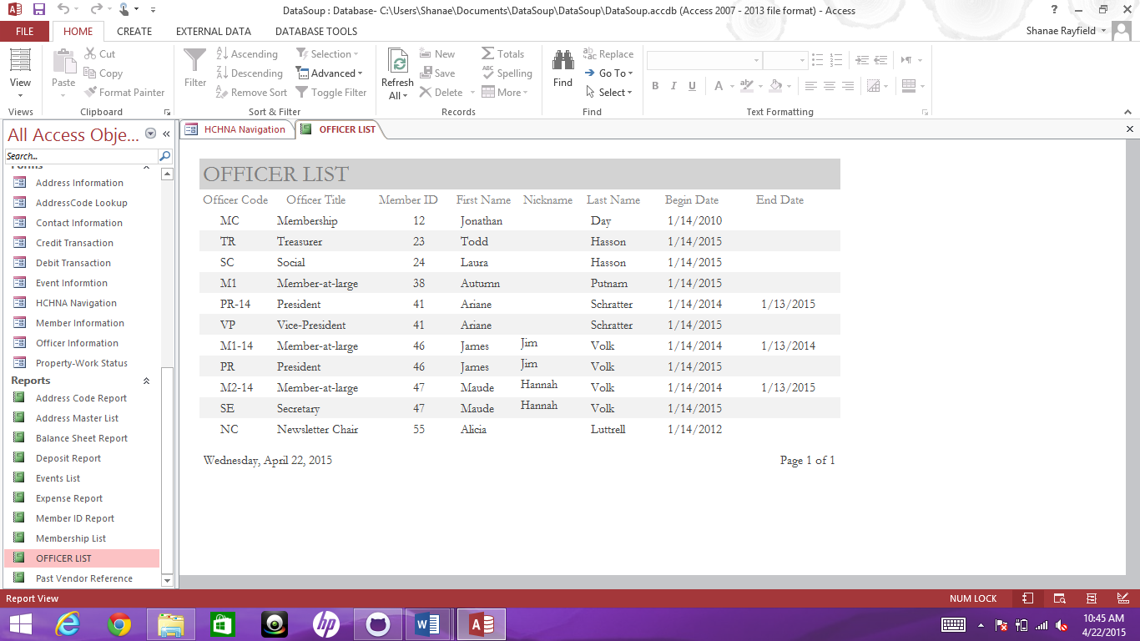

Report Name: Officer List

Created By: Kyle Tuczynski

The purpose of this report is display the officers of the association. Specifically, it shows the a detailed account of all officers past and present.

The fields included in this report are:

Officer Code

Officer Title

Member ID

First Name

Last Name

Nickname

Begin Date

End Date

This report can aid in association meeting, decisions and accountability. It also provides clarity to codes such as officer code and member id.

Report Documentation

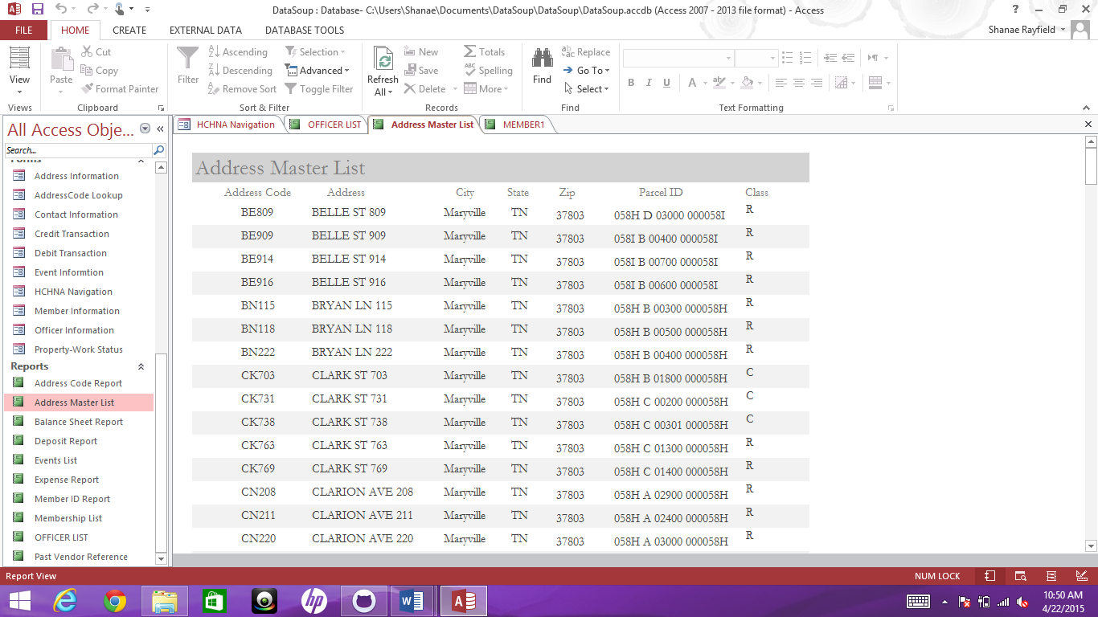

Report Name: Address Master List

Created By: Kyle Tuczynski

This report provides a detailed account of address within the Historic College Hill Neighborhood Association. If you are in need of property specifics this would be a great report to reference.

The fields of Address Master List include:

Address Code

Address

City

State

Zip

Parcel ID

Class

Report Documentation

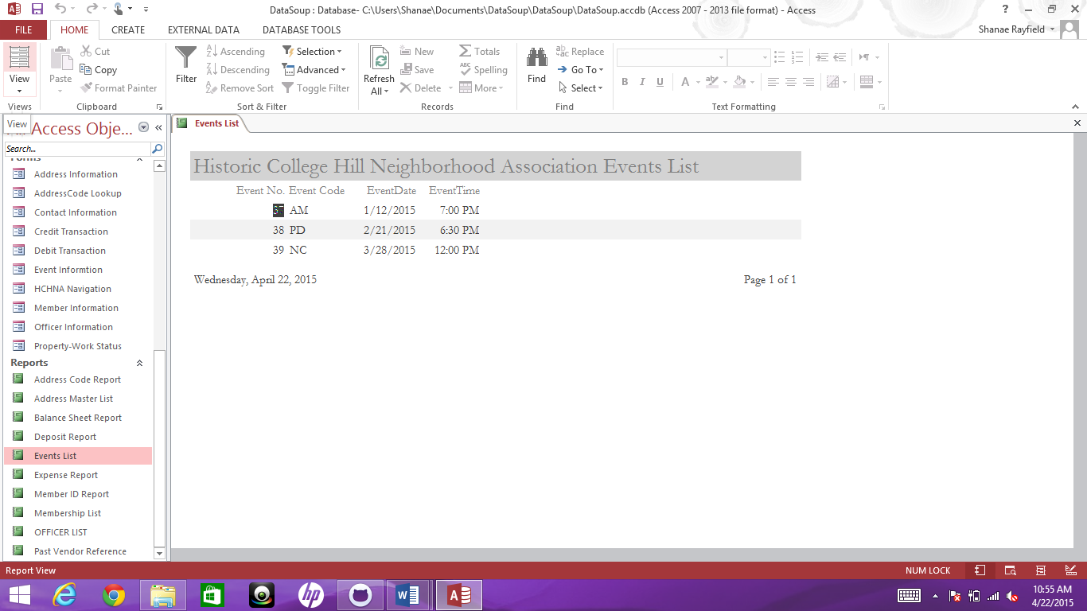

Report Name: Events List

Created By: Kyle Tuczynski

This report gives a list of past events held by the association.

The report Events List includes the fields:

Event Number

Event Code

Event Date

Event Time

Report Documentation

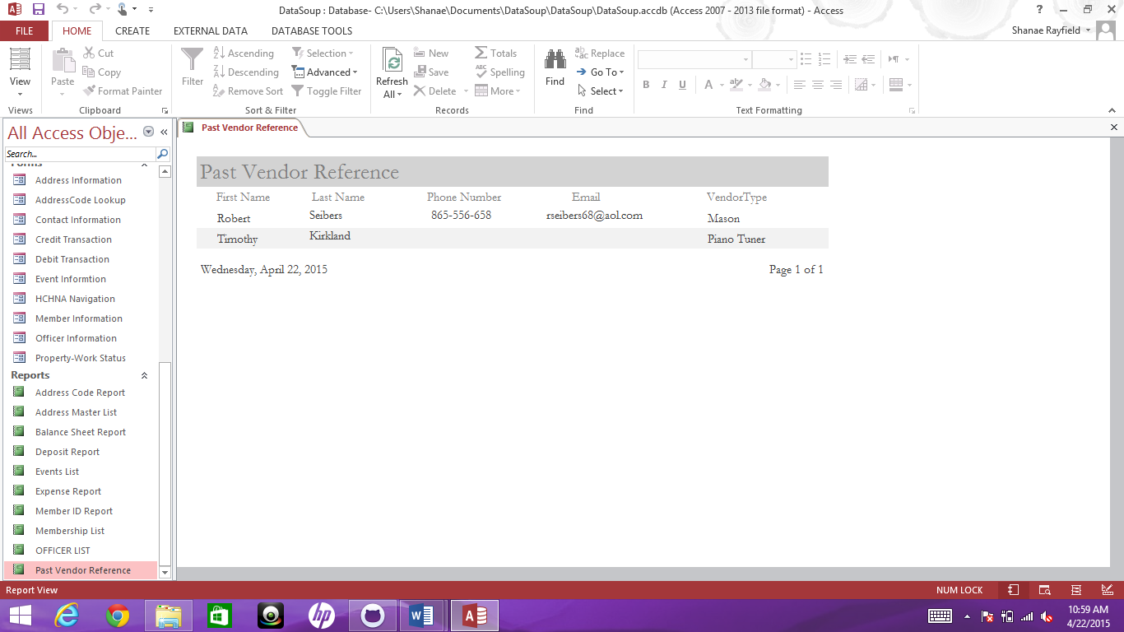

Report Name: Past Vendor Reference

Created By: Kyle Tuczynski

The purpose of this report is to view all past vendors used by the association.

The report Past Vendor Reference includes the fields:

First Name

Last Name

Phone Number

Email

Vendor Type